FULL MEETING of
BRETTENHAM AND KILVERSTONE PARISH COUNCIL
held in the Kilverstone Estate Office
on Tuesday 21st July 2026 at 19:00

- Attendance

Councillors Present: Cllr Bick (Chair), Cllr Skirving (VC), Cllr Exton, Cllr Gordon, Cllr Hughes, Cllr Todd, Cllr Wright

Also, in attendance: Sarah Fulcher, Cllr Robert Kybird and Cllr Scott Hussey
No members of public were present.

- To receive any Declarations of Interest and requests for dispensations
None

- To approve the minutes of the previous meeting held on 12 May 2026
The minutes of the Parish Council meeting held on 12 May 2026, having previously been circulated to all members, were approved and signed by the Chair.

- To co-opt a councillor to fill the vacant seat
It was resolved to co-opt Cllr Jane Gordon to fill the vacant seat. The Declaration of Acceptance of Office and Declaration of Interests were duly completed.

- Matters Arising (not elsewhere on the agenda)
- NALC Award Scheme
It was agreed that the Parish Council would apply for bronze accreditation in September
- Public Platform for participation

- Finance
  - Payment Approvals
    - Microsoft 365 - £84.99
    - Norton 360 – £75.99
  - Receipts
    - POS rental £100.00
  - RFO’s Report

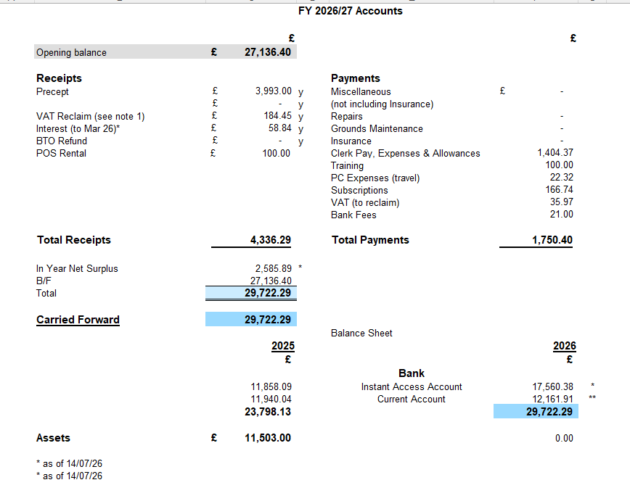

- Clerk’s Remuneration
The Clerk removed herself from the room to allow free discussion.
The Council noted that the Clerk had successfully completed one training course and had passed her three-month probationary period in June 2026.
It was resolved to increase the Clerk's contracted hours from four to six hours per week, to be reviewed after four months.
It was further resolved to move the Clerk to SCP 12 of the NALC Pay Scale. Cllr Bick will review the associated banding requirements.

- Policy Review
  - Standing Orders
  - Financial Regulations
The revised Standing Orders and Financial Regulations, having previously been circulated, were reviewed by the Council. Subject to a small number of amendments identified by the Clerk, both policies were adopted and will be uploaded to the Parish Council website.

- Planning
- To consider the establishment of a Planning Committee
The Council considered the establishment of a Planning Committee. It was agreed that where planning consultations fall between scheduled meetings, an extension to the consultation period would first be requested. If this was not possible, an additional meeting would be convened to consider the application.
- Neighbourhood Plan
It was agreed that Cllrs Bick, Exton, Skirving and Gordon would form a working party to discuss the neighbourhood plan. A meeting with Andrea is scheduled for early October. Therefore, the group will need to meet a couple of times before this date to discuss proposed amendments to the Neighbourhood Plan before this meeting. Cllr Bick will send around a form for proposed dates and times for the coming meetings to the Cllrs.
The Clerk will investigate the broken Neighbourhood Plan link on the website and update it as necessary.
- Local Plan – Regulation 19
Consultation period runs from 31 July to 16 Sept 2026
Consultation drop-in events will be held as follows:
  - 17 August (9.30am-1.30pm): Thetford Library
  - 20 August (9.30am-1.30pm): Dereham Library
  - 21 August (9.30am-1.30pm): Swaffham Community Centre
  - 26 August (9.30am-1.30pm): Watton Library
  - 28 August (9.30am-1.30pm): Attleborough Library
  - 3 September (1-6.30pm): East Harling Old School Hall
    - 8 September (1-6.30pm): Breckland Council office, Dereham – focussed on East Tuddenham growth proposals
  - 9 September (4-7.30pm): Breckland Council office, Dereham

It was agreed that a notice would be placed on the noticeboards to advise the parishioners of this to encourage attendance.
Members asked Cllrs Kybird and Hussey whether the Local Plan would remain in place following Local Government Reorganisation. They advised that the current plan would continue for approximately two years, after which a new plan may be produced.
Cllrs Kybird and Hussey left the meeting at 20:40

- Kilverstone Almshouses Update
The Almshouses Trust report was received and noted.

Kilverstone Almshouse Trust 211599
Report to B&KPC Committee Meeting 21-07-26
Date 18-07-26

Financial.
Balance at last meeting. £14,987.45
Money Out
Caroline Hughes Key safe for No.2 £15.23
Transfer to Instant access savings £10,000
Total Money Out £10,015.23
Money in.
Rent No.1 May 26 £628.12
Rent No.2 June 26 £628.12
Rent No.1 June 26 £628.12
Rent No.2 July 26 £628.12
M & G Dividend £34.40
Total Money in. £2,546.88
Balance at 18-07- 2026 £7,519.10

Investments
M & G investments at 31-03-26 £3,752.80
CCLA investments at 31-03-26 £40254.14
Lloyds Instant Access Account at 18-07-26 £50,318.25

Maintenance
Potholes at the drive entrance to the Almshouses were levelled and paving slabs at the entrance to No.2 were re- bedded to remove a potential trip hazard.
Three tenders were received for the internal decoration of the Almshouses from local contractors. The lowest tender was accepted. The selected contractor cannot undertake the work until late 2026 / early 2027.

Beneficiaries.
Beneficiaries advise that internal redecoration will be delayed until the selected contractor can start the work in late 2026/ early 2027.
Beneficiaries advised that the Weekly Maintenance Contribution will remain at £144.95/week until the next review on 30 April 2027.

Trust Management
To assist the beneficiaries in applying for a grant to cover the upgrading of existing insulation levels to the Almshouses, the adding of Solar Panels and Battery Storage of solar electricity, approaches to the Norfolk Warm Homes Team remain ongoing. The application process is proving to be very difficult in that it is usually tenants of private landlords that apply. The Beneficiaries will be first to make such an application and the decision as to whether they comply with the grant criteria for the application has been passed to the Government Department of Energy for assessment. We are advised that this could take a considerable time for a decision to be passed back down to the Warm Homes Team. Unfortunately, the grant for this financial year has now been fully allocated. If we achieve approval from the DoE we will be considered for the next available grant post April 2027.

- Greater Thetford Partnership
Nothing to report as the meeting has been postponed until 29th September 2026.

- Reports from Members
- Rural, Environmental and CPRE.
Nothing to report
- Community Safety
Cllr Bick reported that one incident had been recorded within one mile of IP24 2RR since the previous meeting. Incident details unknown due to a change in website and reporting.

- Correspondence for information
None

- Date of Next Meeting
The next meeting will be held on Tuesday 8 September 2026 at 7.00 pm.

